# KitManager Supports GitLab now!

## For Markets and Platform, you guys need to do the following things:

### Migration your application code from SVN to GitLab.

### Add the “svc.kitmanager” as “Master” role to access your project

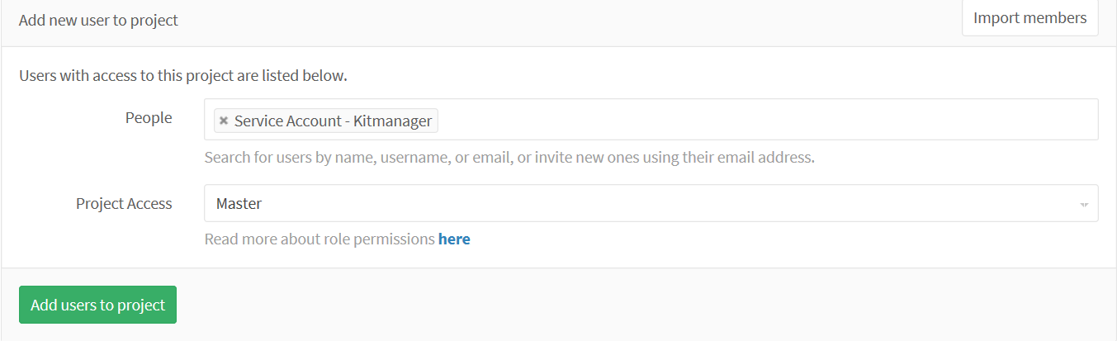

### Notice DBE Team, we will update the configuration of your project [Repository](javascript:window.open('../../Repository/Create',%20'Create%20Repository%20-%20Kitmanager',%20'width=700,height=700');) from DB Side, you can’t start your work before you receive the response from DBE Team.

### Once you get the reply , you can start to create new release

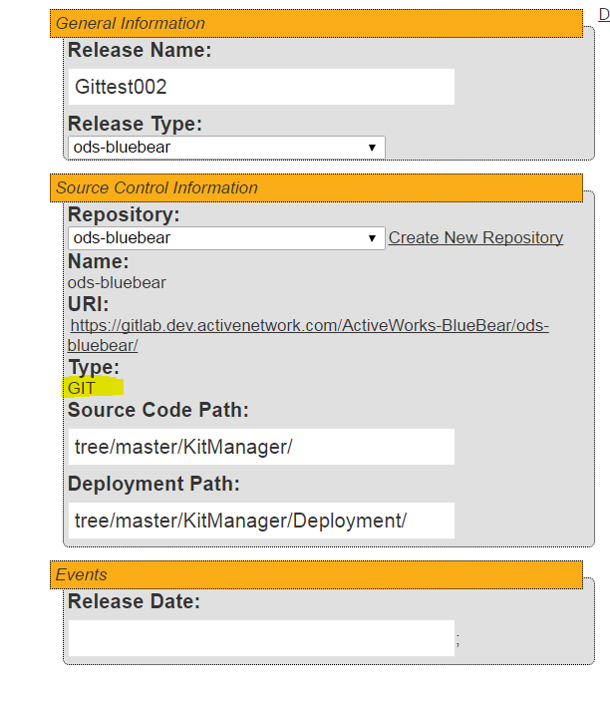

You notice the repository Type now show “GIT”, input the real path for “Source Code Path” and “Deployment Path”, For “tree/XXX/KitManager/” And “tree/XXX/KitManager/Deployment/”, you can use your real branch name to instead of “XXX”,

For instance , if your branch name is “master”, your input should be like the picture as display

But if you branch name is “branch1” , so they should be “tree/ branch1/KitManager/” and “tree/ branch1/KitManager/Deployment/”

### Create new kit and add file for your kit

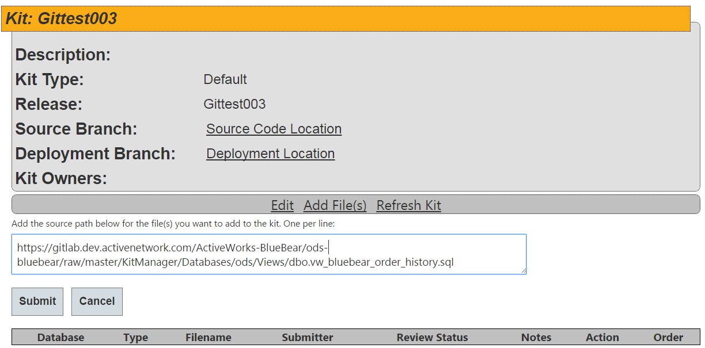

How to get the file url?

5.1 Navigate to the real the file path from gitLab Server

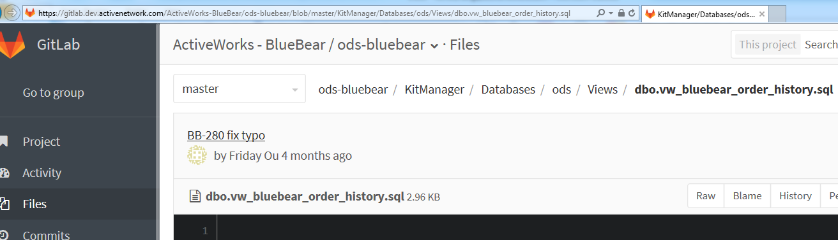

* 1. click the “Raw” link button ,you will open a new tab page in your browser

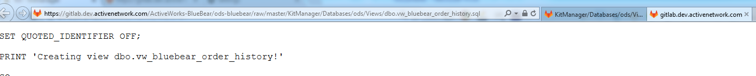

* 1. copy the file path from address , and paste it on source path.

### Click “Submit” button, if you provide the correct source file path , you should see the following message :

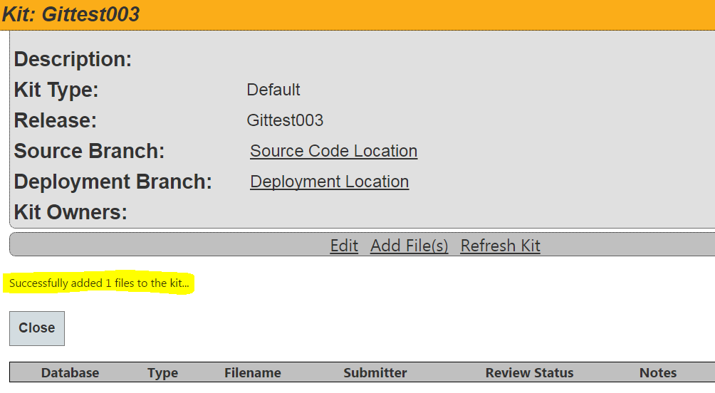

### Refresh kit now.

This phase always need to wait 1~2mins.

### Use Jenkins to build your application code, get the Version number to execute kitmanager.

## For DBE , need to do the following things:

### modify the configuration data(For existing kitmanager Project )

If you receive any request from anyone who is going to use GitLab [Repository](javascript:window.open('../../Repository/Create',%20'Create%20Repository%20-%20Kitmanager',%20'width=700,height=700');) , you need to modify the configuration data using the following statement:

--/****** Script for SelectTopNRows command from SSMS ******/

SELECT TOP 1000 [RepositoryID]

,[RepositoryTypeID]

,[Uri]

,[CreatedDate]

,[ModifiedDate]

,[DefaultReleaseTypeID]

,[Name]

FROM [EDM_Admin].[dbo].[Repositories]

WHERE name ='BlueBear Service'—release type

UPDATE EDM_Admin.dbo.Repositories SET Uri='https://gitlab.dev.activenetwork.com/ActiveWorks-BlueBear/bluebear-management-service/',--you can get this from dev

RepositoryTypeID=2

WHERE RepositoryID=68

### Create new release type (for new project )